  - Quiz 1 Advance Database Management System Theory
BSCS_5 Instructor
Noor Mustafa Rajpar
Q1- Discuss MySQL Replication and Clustering Techniques in detail. Explain their key characteristics, working mechanisms, advantages, and limitations with suitable examples.
Q2-Discuss the following Terms Integrity , High Concurrency, Massive Scale :
Q3- List At least 3 objects name which helps to store unstrutured data using mysql.
Q4- Discuss Query Optimization Techniques with at least 2 examples
Q5- Discuss the Role Of Distributed systems in ADBMS .
Q6. Discuss ACID Property in detail . with proper real world examples on each .
Q7. Explain Horizontal Scalibility and Vertical Scalibitly and which is used in ADBMS ? and write key characterstics of it at l least 4 And Discuss the term transparency on it .
Q8. What is Bottleneck problem in Vertical Scaling ! discus in detail with proper examples
Q9. Discuss the Limitations of Tradational RDBMS. In detail with proper examples and how ADBMS solve that problem .
Q10. Discuss Relational Algebra in detail and it’s Operations In detail unary and Binary operations with Proper Examples .
For each Operations write at least 2 examples.
Q11:Joins
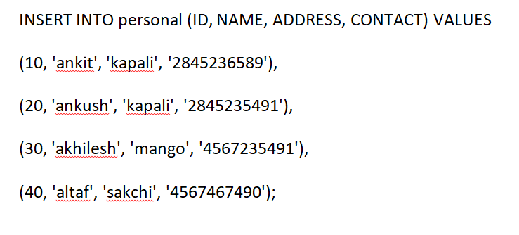
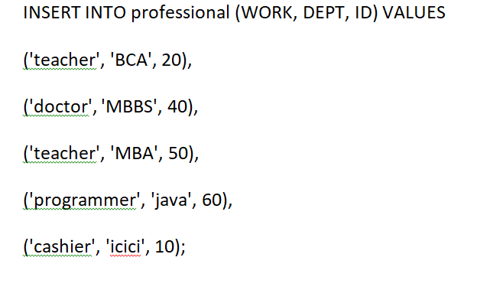

1:After Applying Equi Join Write it’s Output for also explain how Query works
2:After Applying non-Equi Join apply > Condition Write it’s Output and also explain how Query works
Equi join Query --
SELECT name, address, work
FROM personal, professional
WHERE personal.id = professional.id;
--Non-Equi join 4
SELECT personal.name, professional.work
FROM personal, professional
WHERE personal.id >professional.id;

